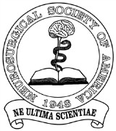

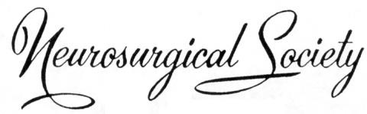

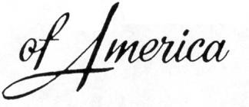

ANNUAL MEETING THEME: “GOING DEEP; NUANCE DERIVED FROM FOCUSED PRACTICE”

Annual Meeting, June 14-17, 2026, Grand Cayman
ABSTRACT SUBMISSION FORM
DEADLINE FOR ABSTRACT SUBMISSION: FEBRUARY 1ST, 2026

INSTRUCTIONS
Authors: (Last Name, First Name)
Name of Presenter:
Institution of Presenter:
E-mail address of Presenter:
NSA Member □ / Guest □
If Guest, please give name of sponsoring member:
If Guest and interested in membership, have you presented at the NSA yet? Yes □ / No □

Abstracts should be limited to 250 words and include the following:
INTRODUCTION: a brief description of the rationale for the study
METHODS: the methods used to obtain the data, or conduct the study
RESULTS: a summary of the results
CONCLUSION: conclusions supported by the results

The length of presentation will be 8 minutes with 2 minutes assigned for discussion and questions.
SPIEGEL SPECIALs are 5-minute vignettes of a specific technical surgical nuance or introduction of a novel surgical procedure. They are particularly encouraged. The same abstract submission format is used for the Spiegel Specials.

Upon acceptance of your abstract, you will be contacted by our CME provider (Kansas University Medical Center) to submit your disclosures & conflicts of interest statement.

Please submit your abstract as a word document by email to Ben Kennedy at KENNEDYBC@chop.edu

